Assignment 7
Brian Batinchok (A)
Ryon Riley (A)
Jesse Lambert (B)
Ian Vigrass (B)
Alex Lorenzo (A)

- Configure IP address for router 1 and set IP for PC1.\
LAN-A:
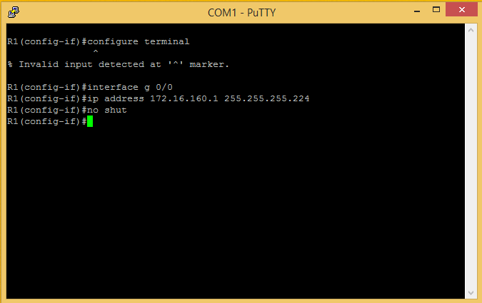
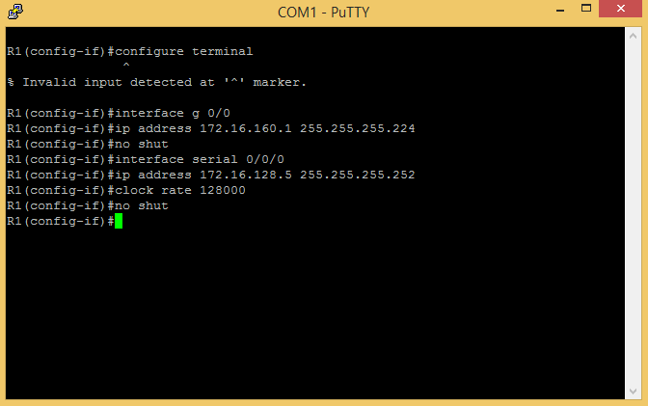
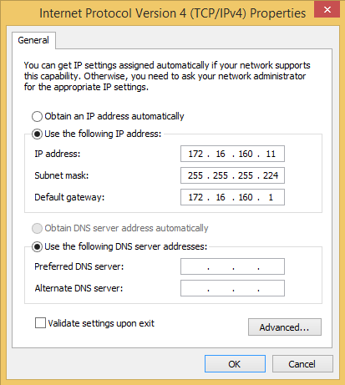

LAN-B:
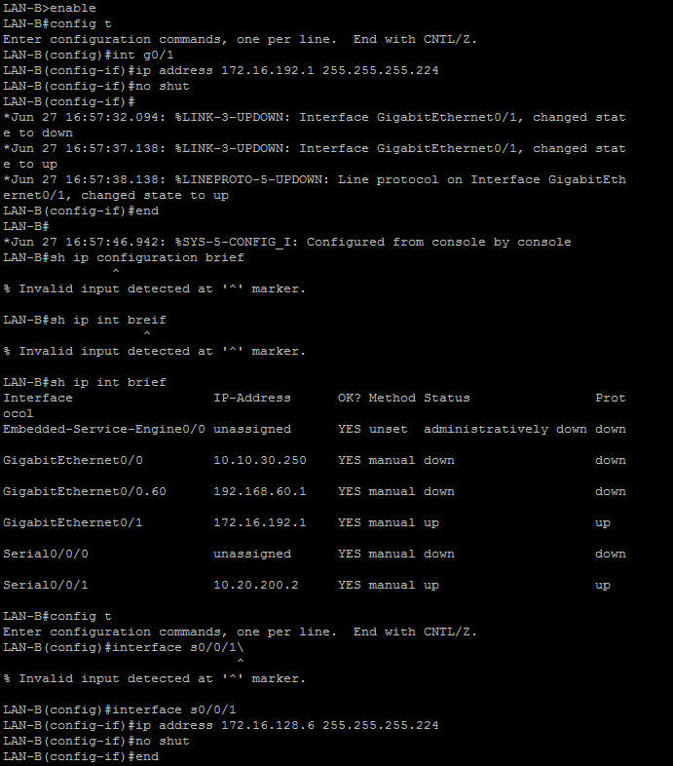
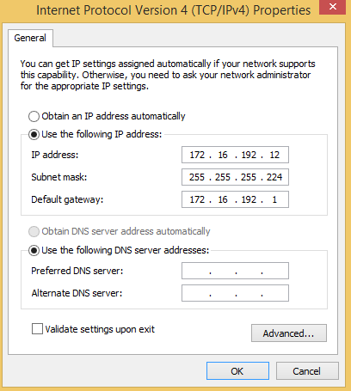

- Configure RIPv2 routing for the network for Router 1.
LAN-A:
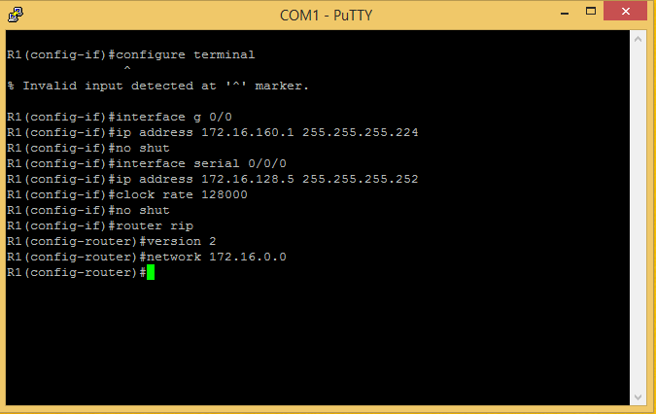

LAN-B:
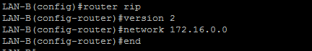

- Verify the network routing is properly configured using “sh ip route”
LAN-A:
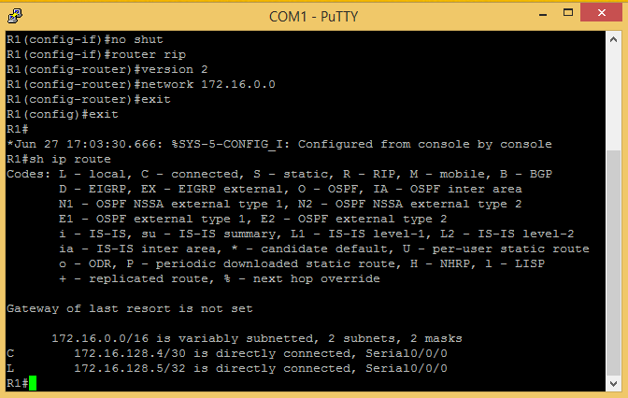
Ping router 1 and 2 and use sh ip int brief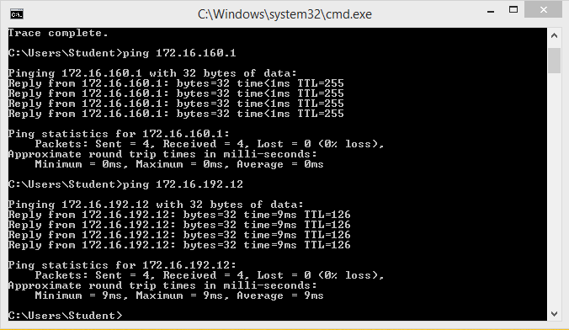
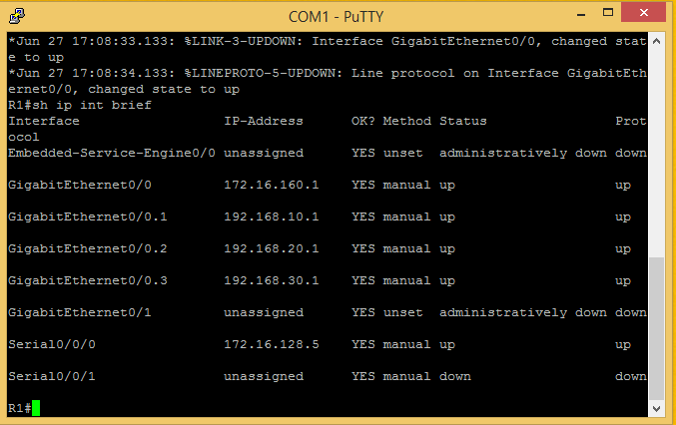

LAN-B:
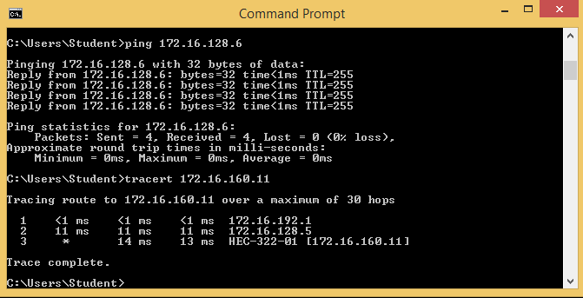
- Create ACL on router 1 and s0/0/0 interface
LAN-A:
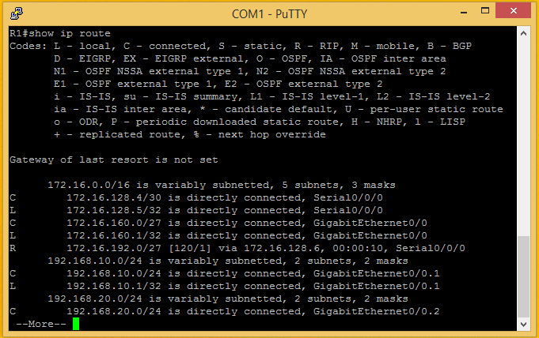

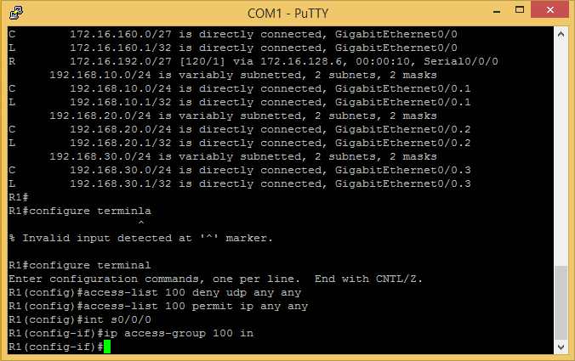

LAN-B:
- Create ACL on router 1 that will deny Telnet

LAN-A:
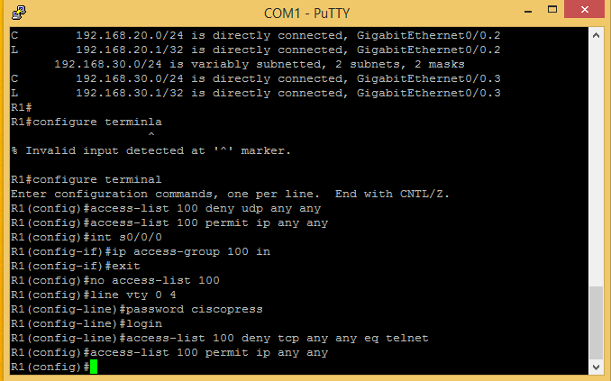
LAN-B:
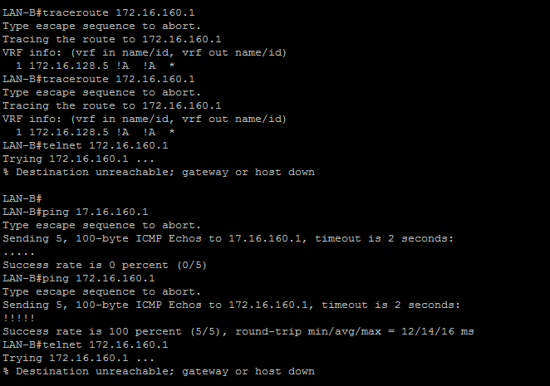
- More ACL stuff:
LAN-A:
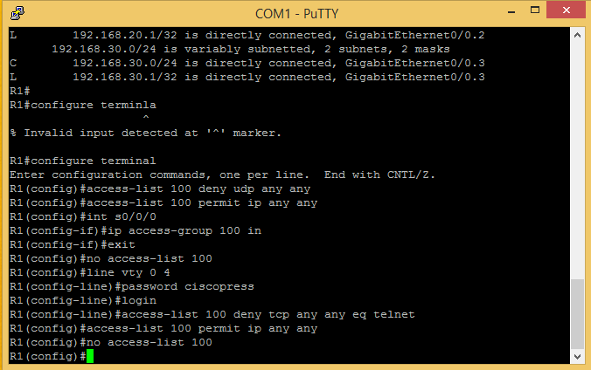
LAN-B: 